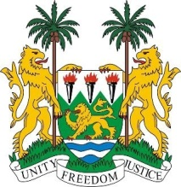
SIERRA LEONE
26th session of the UPR

REPUBLIC OF MOLDOVA

STATEMENT BY SIERRA LEONE

4 November 2016

Mr President,

Sierra Leone welcomes the delegation of the Republic of Moldova to this UPR session and thanks them for their presentation.

We commend the government on developing a new National Human Rights Action Plan (2017 – 20120), and equally, on establishing the Government Strategy on Child Protection (2014 – 2020) which is focused on preventing and combatting violence against children.

While the Republic of Moldova is facing challenges as regards the Transnistrian region of the country, it is encouraging to note the government’s expressed commitment to finding human rights solutions through dialogue and cooperation.

Sierra Leone believes more can be done to further ensure the participation and inclusion of the Roma in decision-making processes and we would in this regard, encourage the Republic of Moldova to implement at its earliest convenience, the National Action Plan for the Roma (2016 -2020).

Sierra Leone makes the following recommendations:

- Ratify and accede to the ICPPED and the ICRMW.
- Implement legislation to abolish, and effectively combat early and child marriage.
- Establish clear legislation criminalising the hate crimes and ensure all incidents of religious hate speech are investigated.

To conclude, Sierra Leone wishes the Republic of Moldova a successful completion of this second UPR cycle.

Thank you, Mr President.

